

Action Log

|  |  |
| --- | --- |
| Item | Action taken |
| Make sure all members of staff are aware of the Sugar Smart message and are proactive in its promotion around the school using the resources available on the Sugar Smart website. | Date: |
| Offer the free Sugar Smart ambassador training to members of staff allowing them to be champions for the campaign. | Date: |
| Enable the staff to take part in a cooking course and promote low or sugar-free recipes. | Date: |
| Get accredited by an external organisation to ensure the food and drink you serve is healthy for people and planet. You can be accredited by **Food for Life** and **Sustainable Restaurant Association.** | Date: |

[](https://www.sustainweb.org/)[](http://www.sustainablefoodcities.org/)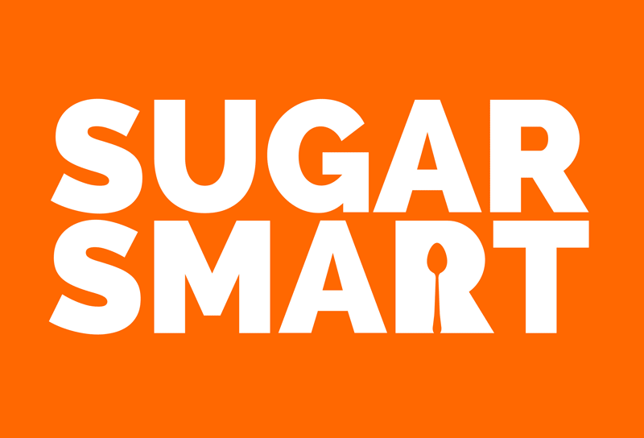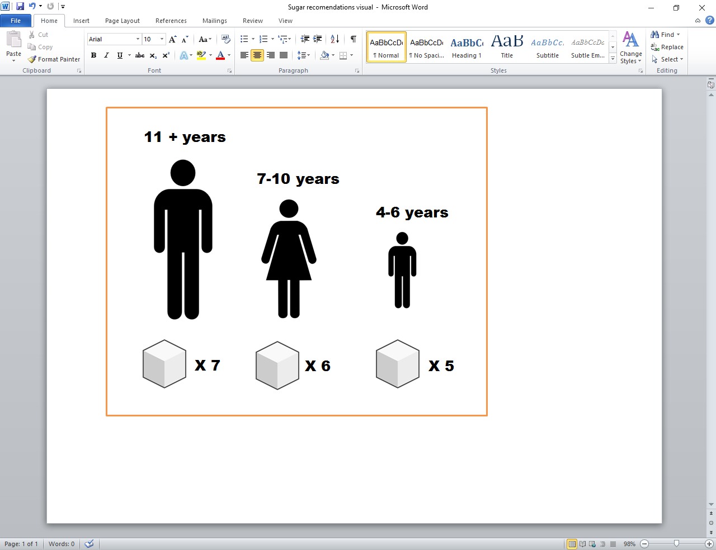

The SUGAR SMART website provides sugar facts, case studies from within the campaign and all the resources you need to make your school Sugar Smart! For inspiration and support visit - www.sugarsmartuk.org

Shockingly, on average children are eating up to 3 times this amount and such overconsumption increases the risk of health outcomes such as obesity, type 2 diabetes and tooth decay.

The school environment presents a substantial opportunity to positively influence food choice and reduce daily sugar consumption through simple changes that make the healthy choice the easy choice.

The following table provides a space to record any of the actions that have been adopted from the Sugar Smart school audit tool or any future actions that may take place.

Currently the government recommends that the maximum daily (added) sugar intake should be no more than …



Action Log

|  |  |  |  |
| --- | --- | --- | --- |
| Item | Action taken | Item | Action taken |
| Sign your school up to schemes such as the **Workplace Wellbeing Charter** or **London's Healthy Workplace Charter.** | Date: | Replace sugary items with healthier options and display signage about sugar content in everyday food and drink. | Date: |
| Hold a Sugar Smart week to introduce the campaign to the school. This could include a sugar reduction challenge, such as giving up sugary drinks for a whole week. | Date: | Lease with the catering staff and request that they review the menu aiming to reduce the sugar content of their recipes. | Date: |
| Ensure that water is always available during meal times and is promoted as the drink of choice. | Date: | Enforce a stay on site rule at break times and lunchtimes so children are unable to purchase sugary foods and drinks from vendors in the locality. | Date: |
| Consider banning sugary drinks. If a complete ban is not realistic consider introducing a levy. You may increase the cost of sugary drinks by 15p and donate any profits to charity. | Date: | Implement a packed lunch policy in your school to ensure children have a healthy and nutritious lunch. | Date: |



Action Log

|  |  |  |  |
| --- | --- | --- | --- |
| Item | Action taken | Item | Action taken |
| Discourage the bringing in of sweets and cakes on birthdays and suggest alternative celebrations. | Date: | Spread the word in your community on the dangers of too much sugar by organising events or stunts. | Date: |
| Getting the parents involved is crucial! Write an article in the school newsletter explaining how your school is planning to be more Sugar Smart and invite parents to join the campaign and offer up any suggestions. | Date: | Ask a class to prepare a Sugar Smart assembly to deliver to the rest of the school. | Date: |
| Invite outside speakers into the school such as local chefs and dental practitioners to engage the children with the importance of being sugar smart. | Date: | Get the children to make viral content such as videos or interviews to share on social media channels. | Date: |
| Use low sugar recipes to do cookery demonstrations and help children and adults within the local community make better choices for their meals. | Date: | On a termly basis choose a volunteer from each class to be a sugar monitor. This role could include making sure sugary rewards don’t leak back into the classroom, maintaining and updating a sugar smart notice board and meeting with the other monitors each month to discuss the success of and potential for any changes. | Date: |



Action Log

|  |  |  |  |
| --- | --- | --- | --- |
| Item | Action taken | Item | Action taken |
| Here is space for you to record any Sugar Smart action you may come up with. | Date: |  | Date: |
|  | Date: |  | Date: |
|  | Date: |  | Date: |
|  | Date: |  | Date: |