Press Release
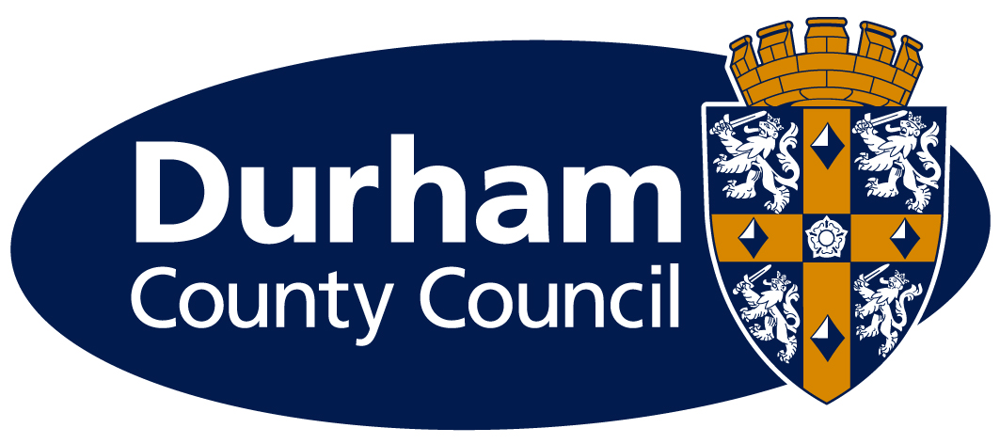
Date: | Monday, 17 July
Contact: | Helena Hickey
Direct Tel: | 03000 264 312
email: | Helena.hickey@durham.gov.uk

Campaign launched to tackle sugar consumption

People across the county are being encouraged to cut down on sugar and raise awareness about its impact on health as part of a new initiative.

Organisations, businesses and individuals across the county are being asked to join the SUGAR SMART Durham campaign by taking actions to help make it easier for people to reduce their sugar consumption.

Consuming too much sugar and too many foods and drinks high in sugar can lead to weight gain, which in turn increases the risk of heart disease, type 2 diabetes, stroke and some cancers. It is also linked to tooth decay.

Food Durham is a partnership that aims to encourage a healthier, greener and fairer food system that supports the local economy. Food Durham is coordinating the local Sugar Smart campaign and as a key partner, Durham County Council has already pledged to take action to:

- Promote free drinking water
- Reduce high sugar options in vending machines
- Promote healthy meal deals
- Reduce advertising of high sugar products
- Stock healthier food and drink
- Provide clearer information about the sugar content of food and drink

The initiative, which is led by the Jamie Oliver Food Foundation and Sustain, aims to make it easier for people to make healthier choices by making sugary produce less available or less well promoted.

Dr Liz Charles, Project Manager for Food Durham at Durham Community Action said: “I am delighted that Food Durham is co-ordinating the SUGAR SMART campaign across the county. Changing our food habits is never easy but every small action from our partners will help us all achieve diets that will do us less harm and make us more aware of the hidden sugar in everyday foods.”

Continues…

Councillor Lucy Hovvels, Cabinet member for adult and health services, said: “We know that there is no single solution to tackle obesity and the SUGAR SMART Durham campaign is a great opportunity for us to work together to help our communities reduce their sugar intake.

“I would encourage everyone to pledge their contribution to the initiative and help raise awareness around the risks of consuming too much sugar.”

Any groups or individuals who want to find out more the campaign, which runs until summer 2018, should visit www.sugarsmartuk.org

People are also invited to fill in the SUGAR SMART survey at www.surveymonkey.co.uk/r/GK9WJFB where they will be entered into a prize draw.

ENDS

Notes to editors: Food Durham is the County Durham Food Partnership, comprised of individuals from different sectors who have an interest in any and all matters relating to food – its provenance, environmental, social and economic impact, animal welfare, and food justice – i.e. the whole food system.

Food Durham is hosted by Durham Community Action, a charity that has been providing support to communities across County Durham since 1935.

SUGAR SMART is a campaign by Jamie Oliver Food Foundation and food charity Sustain working with councils, businesses, institutions and other sectors to help reduce overconsumption of sugar in their local areas. SUGAR SMART supports local campaigns to transform their food environment and raise public awareness of the impacts of consuming too much sugar.

Any organisation can pledge to become SUGAR SMART – from councils and schools to restaurants, hospitals and independent companies. Individuals interested in supporting their local campaigns can also join the SUGAR SMART newsletter or sign up as a local volunteer via the website.

