SUGAR SMART Kensington & Chelsea Know Your Labels quiz

Remember: more than 22.5g of total sugars per 100g is high, less than 5g of total sugar per 100g is low, and between 5g and 22.5 is medium!

CEREAL
Use the label on the right and the guide above to answer the following questions.

1. How many grams of sugar are in 100g of this breakfast cereal?
___________________________________________________________________

2. How much sugar is in a single serving including ½ cup of reduced fat milk?
___________________________________________________________________

3. Is this a high, medium or low sugar product? (circle your answer)
High
Medium
Low

4. If a five year old boy had a bowl of this cereal for his breakfast, how many more grams of sugar can he eat to stay within his daily recommended amount?
___________________________________________________________________

5. Can you think of three SUGAR SMART breakfast options?
i. __________________________________________________________________
ii. __________________________________________________________________
iii. _________________________________________________________________

SMOOTHIE
Use the label on the right and the guide at the start to answer the following questions.

1. How many grams of sugar are contained in the whole 250ml bottle? _________________________________________________

2. How many sugar cubes is that? _________________________________________________

3. If a five year old girl drank the whole drink would they be above or below their daily recommended amount of sugar? _________________________________________________

4. Can you think of three SUGAR SMART drinks she could have instead?
i.________________________________________________
ii.________________________________________________
iii._______________________________________________

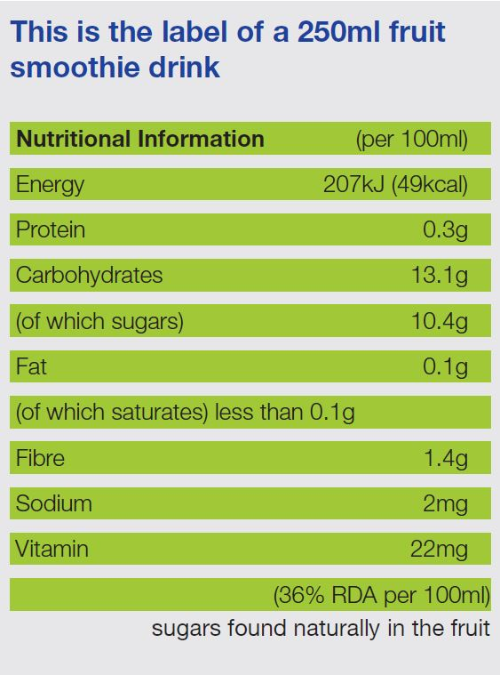
CAKE
Use the label on the page overleaf and the guide at the start to answer the following questions.

1. How many different types of sugar are in this product?
_________________________________________________

2. List the forms of sugar below:
_________________________________________________

3. How many cubes of sugar are in a portion of this cake?
_________________________________________________

4. Is this a high, medium or low sugar product? (circle your answer)
High
Medium
Low

5. If a ten year old girl had a portion of this cake how many more grams of sugar could she have to stay within her daily recommended amount?
_________________________________________________

6. Can you think of three SUGAR SMART snack options she could have instead of cake?
i.________________________________________________
ii.________________________________________________
iii._______________________________________________

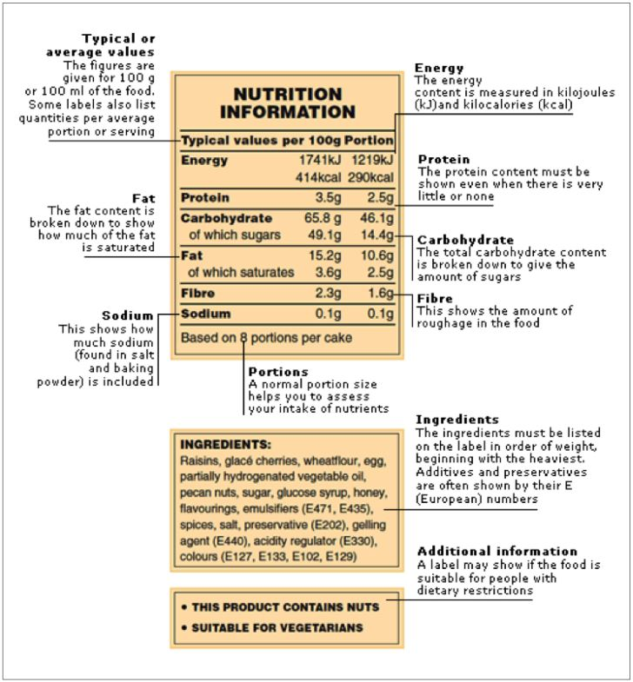

SUGAR SMART Kensington & Chelsea Know Your Labels answer key

CAKE
1. 36.5g

2. 18g

3. High

4. 1g

5. See Change4Life Sugar Smart Breakfast Recipes and Jamie Oliver’s Healthy Breakfast ideas for more inspiration:
https://www.nhs.uk/change4life/recipes#c5dJ5vLMLzuc3rr3.97
https://www.jamieoliver.com/recipes/category/course/healthy-breakfast-ideas/

SMOOTHIE
1. 26g

2. 6.5

3. Above

4. Healthier drinks include water, milk and water flavoured with a small amount of juice. You can also make smoothies with fruit and plain yoghurt or milk. See Change4Life Be Sugar Smart swap tips for more inspiration:
https://www.nhs.uk/change4life/food-facts/sugar#qDvtzrF4SYAvUABr.97

CAKE TIME
1. 3
2. Sugar, glucose syrup, honey
3. High
4. 9.6
5. See Change4Life Sugar Smart Healthier Snacks recipes and Jamie Oliver’s Healthy Snack ideas for more inspiration:
https://www.nhs.uk/change4life/food-facts/healthier-snacks-for-kids/fruit-and-veg-snacks
https://www.jamieoliver.com/recipes/category/course/healthy-snack-ideas/

