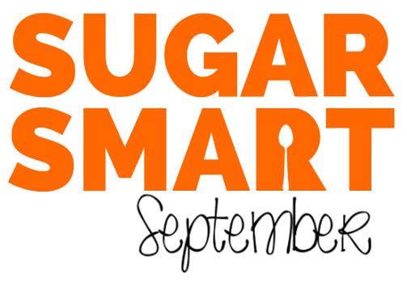

The SUGAR SMART team often hears from individuals concerned about how much sugar they or their children consume. However it can be so hard to cut down on added sugar, as it is often hidden in foods without us realising, and sugary products are marketed and promoted to us in a way that means we find them very hard to resist.

If this sounds familiar, join us for SUGAR SMART September! We are encouraging people to be smart about their food choices and try to reduce the amount of free sugar eaten during September.

This “free” sugar is any sugar that is added to foods at home or by the producer, plus sugar naturally present in honey, syrups, and fruit juices. It does not include sugar naturally present in milk or whole fruit and vegetables.

Included below are some suggestions on what your SUGAR SMART September might look like, some guidance and tips to help you through the month and a chart you can print out to monitor your progress with your family, friends or colleagues.

Remember to let us know how you get on via social media!

@sugarsmartuk
#SugarSmartSeptember




SUGAR SMART September options

No Spoons Option
Completely cut out added sugar from your diet for the whole of September!

Healthy Balance Option
Completely avoid added sugar during weekdays, with moderate treats only during weekends.

Super Seven Option
Eat less than the maximum recommended 7 teaspoons of added sugar per day. This is a good option to get started on for long term Sugar Smart eating.

Easing In Option
Cut out added sugar during working hours – particularly suited to those office workers who are tempted daily by office treats!

Set your own Challenge
Do you have your own idea for a challenge? Ditching fizzy drinks or cooking from scratch to avoid hidden sugars in popular foods? Set your goal and let us know.

Guidelines

SUGAR SMART September involves avoiding “added sugar”, including:
- All processed sugar that is added to prepared foods e.g. cereals, soups, sauces, biscuits, chocolate, ready meals, cereal bars
- Honey and syrups
- Alcohol which has had sugar added to it e.g. fruit ciders, alco-pops

In SUGAR SMART September you can eat:
- Sugars found naturally in carbohydrates, including fruit, vegetables and starchy carbohydrates.
- Sugars found naturally in dairy products
- Artificial sweeteners (in moderate amounts)
- Alcohol which has not had sugar added to it after the initial processing

Tips for Being Sugar Smart

Know your labels:
- Check the ingredients list for added sugar – the nearer the top of the list it is, the more the product contains. There are lots of names for added sugar you may find in ingredients lists: sucrose, glucose, fructose, maltose, fruit juice, molasses, hydrolysed starch, invert sugar, corn syrup, honey.

- If a product has more than 22.5g of sugar per 100g, it is high in sugar. Traffic light labelling can make this easier to spot, or you can download the Be Food Smart App: www.nhs.uk/Tools/Pages/be-food-smart

- Watch out for breakfast cereals as they are often high in sugar. Try low sugar versions sugar as plain porridge, no added sugar muesli or shredded wholegrain pillows and add fruit if you prefer it sweeter.

- Watch out for “fruit juice drinks” and smoothies that contain added sugar.

- Be aware of “low fat” products, as these may contain large amounts of added sugar.

Check out Change4Life resources:
- For more information on sugar swaps and facts, visit
www.nhs.uk/change4life-beta/food-facts/sugar

- Download the free Change4Life Food Scanner App, which shows quickly and easily how much sugar, sat fat and salt is inside your food and drink – just by scanning the barcode.
https://www.nhs.uk/Tools/Pages/food-scanner-app.aspx

How much is too much sugar?

The recommended maximum daily allowances for children and adults are:
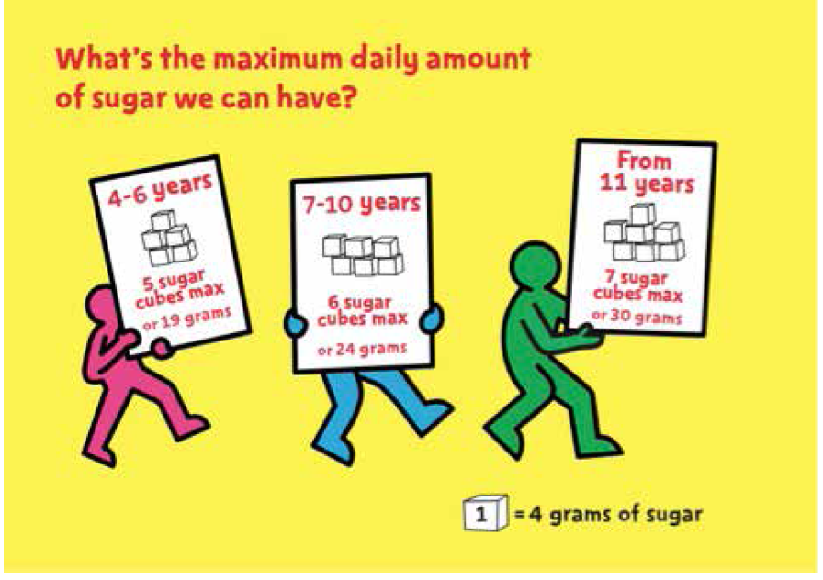
- 4-6 year olds: 5 sugar cubes
or 19g of sugar
- 7-10 year olds: 6 sugar cubes
or 24g of sugar
- 11+ year olds and adults: 7 sugar cubes
or 30g of sugar

